Hive installation

1. Download the bin file link provided - <https://downloads.apache.org/hive/hive-3.1.2/>

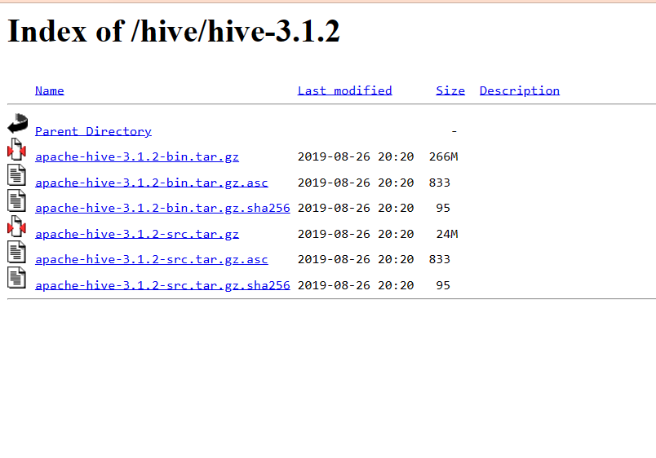

2.After downloading extract the tar file on home folder(because Hadoop is on home folder)

3.Then open the terminal and give the location of hive in bashrc

Command to open bashrc to write on terminal : gedit ~/.bashrc

4.write following on bashrc file :

export HIVE_HOME=/home/siddhu/apache-hive-3.1.2-bin

export PATH=$PATH:$HIVE_HOME/bin

export HIVE_CONF_DIR=/home/siddhu/apache-hive-3.1.2-bin/conf

5.click the save button

6. terminal command : source ~/.bashrc

7.inside hive-env.sh write this

export HADOOP_HOME=/home/shivani/hadoop-3.2.4

8.create warehouse and tmp for db

hadoop fs -mkdir -p /user/hive/warehouse

9.give permissions

hadoop fs -chmod 777 /user/hive/warehouse

10. hadoop fs -chmod 777 /tmp

11.cd $HADOOP_INSTALL

12.cd ~

13.cd $HIVE_HOME/bin

14.schematool -dbType derby -initSchema